The Art of World Reading Comprehension

In a land far away, there was a magical place filled with wonderful art. This place was called the Art of World. Here, the trees were painted with bright colors and the rivers shimmered with every shade of blue. Animals roamed freely, and they too were covered in beautiful patterns. People came from all over to see the fantastic landscapes and to learn from the artists who lived there. The artists used their brushes to create pictures of joy and love, teaching everyone who visited the power of creativity and imagination.

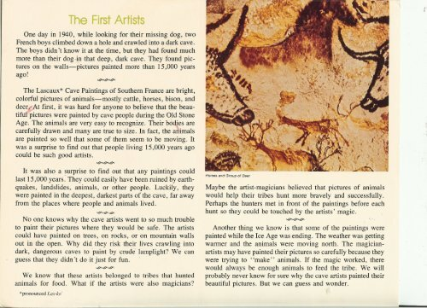

What is the magical place mentioned in the article called?

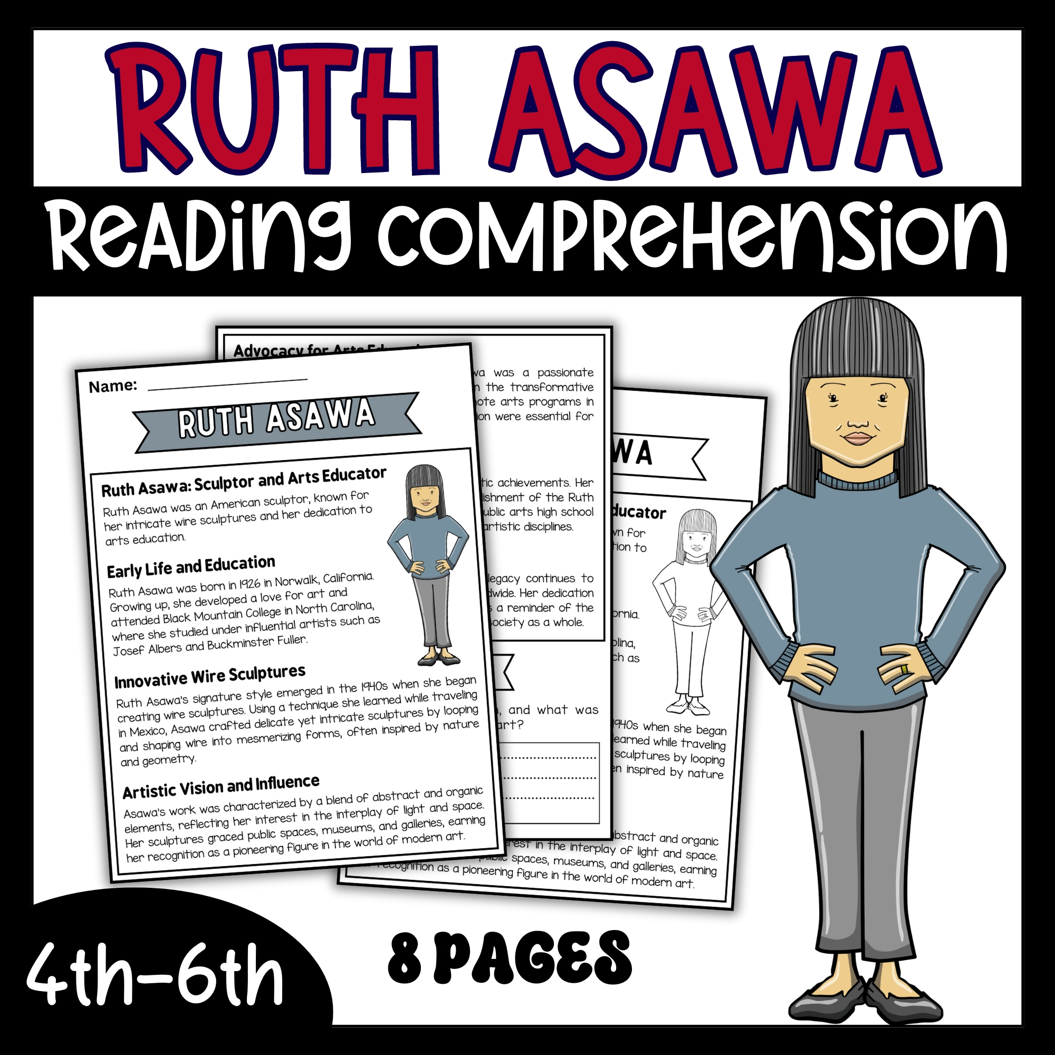

The Art of World

The World of Art

Art Land

Magic World

Correct [The Art of World]

How are the trees described in the article?

Tall and green

Painted with bright colors

Covered with snow

Full of fruit

Correct [Painted with bright colors]

What do the rivers do in the Art of World?

Flow rapidly

Shimmer with shades of blue

Run dry

Are full of fish

Correct [Shimmer with shades of blue]

What did the artists teach in the Art of World?

Math and Science

Joy and Love

History and Geography

Music and Dance

Correct [Joy and Love]

Why did people visit the Art of World?

To see the fantastic landscapes

To go hiking

To swim in the rivers

To meet famous people

Correct [To see the fantastic landscapes]

